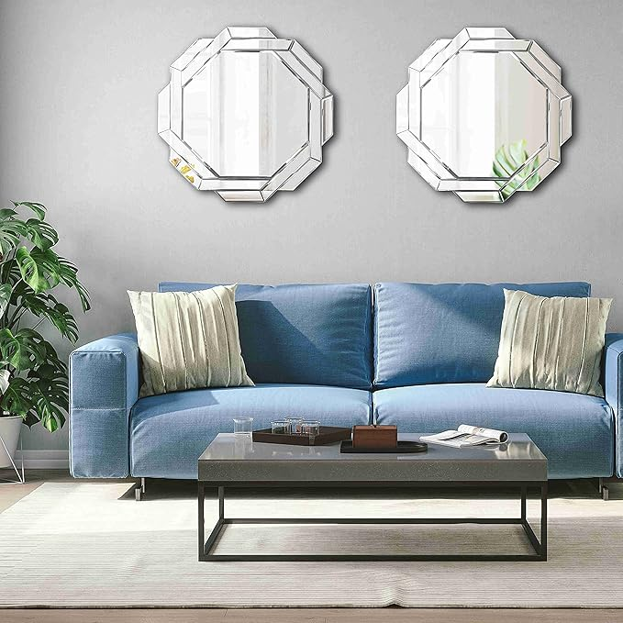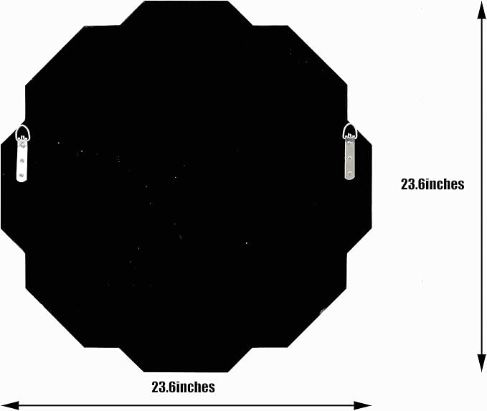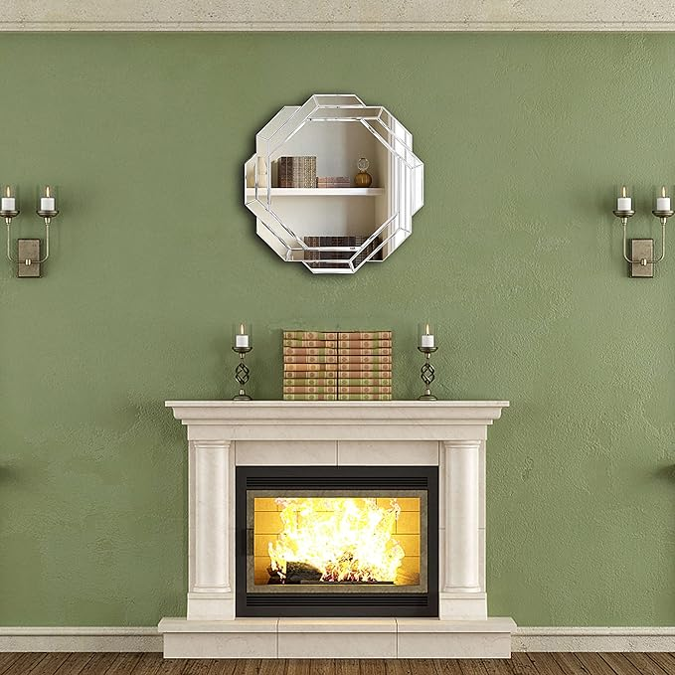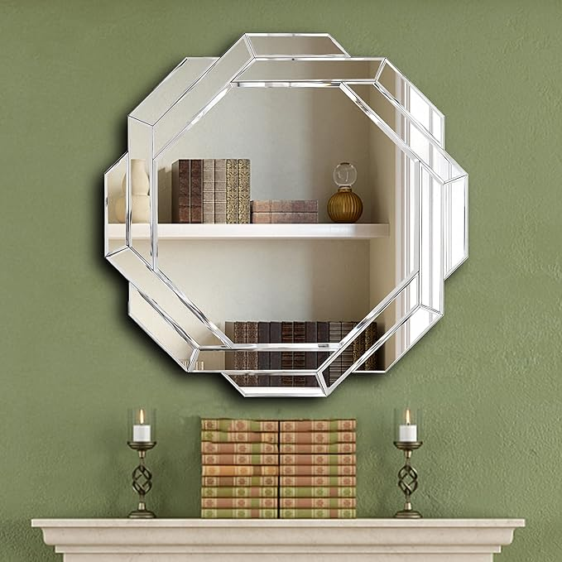

Hlartdecor Helicoid Frameless Beveled Decor Silver Polished Mirror for Wall Decorating(23.6X23.6inches).HFY Hexagon Decorative Mirror.

**PRODUCT DESCRIPTION:**

|  |  |
| --- | --- |
| Brand | FYWDGLART |
| Room Type | Office, Bathroom, Bedroom |
| Shape | Hexagonal |
| Product Dimensions | 23.6"L x 23.6"W |
| Style | Modern |

**About this item**

* PRODUCT SIZE：23.6X23.6X0.79 inches hexagonal silver helicoid wall decor mirror. A floating,frameless wall mirror with small specular slices around.HFY home decoration mirror.
* SOPHISTICATED DESIGN: The decorative mirror is designed with specified small polished slices mirror around the rim.Each edge is carefully beveled. It is sleek, modern and clean in the light.Our solid wood backing design reinforce the product,which is more safety and stable than others.
* EASY TO INSTALL:The helicoid mirror is easy to install. There are two hanger on the back of the mirror so you can hang it on the wall securely and easily.You can combine two helicoid mirror together and hang them on the wall for a more personalized and charming decorative style.
* PERFECT FIT:The wall mirror can be a stylish mirror for bathroom, living room,vanity mirror, bohemian wall decor, gypsy decoration style,mid-century wall decor, bedroom mirror, decorative mirror in office and shop.
* PROFESSIONALLY PACKAGED:The mirror has professionally packaging.Our strong packaging ensures that you receive your products in perfect condition. If there is any defect, please contact us.Your satisfaction is our constant pursuit.Enjoy your shopping.